**CS590BD Big Data Analytics and Applications**

**Lab 2 Assignment**

**By**

**Kommineni Siva Krishna**

**Summary:**

Collection of various information like Time, GPS, Accelerometer, Humidity, Temperature and use a client application to push the data file into HBase.

**Devices used**: Android smart phone, Sensor tag

Select BLE sensor tag app in your mobile then you will be able to detect the sensor in your device as follows.

We can see the data available from various applications as follows.

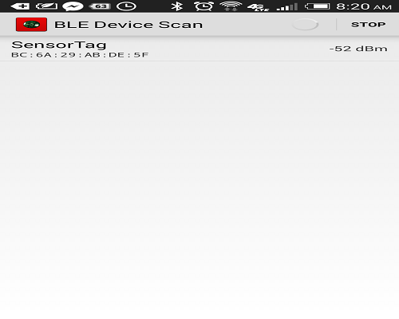

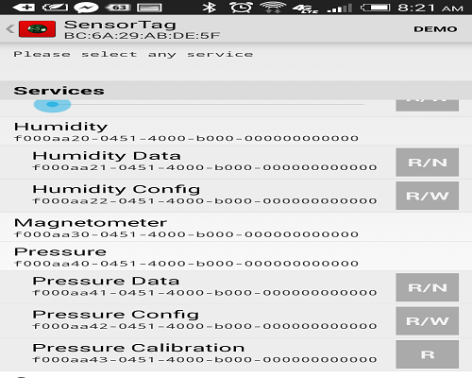

* **Applications Used :**
* Now we are using the applications App1-sensor tag, App3-Android GPS and combined them to read the data into the file.
* We use Astro file manager to collect the data file in our android device. It is an android application to collect the data from the sensor tag in our mobile.
* Modify the existing application such that it can collect the Humidity and Pressure data along with the GPS, Time, and Accelerometer.
* Then after running the application the data is collected in a file as follows.

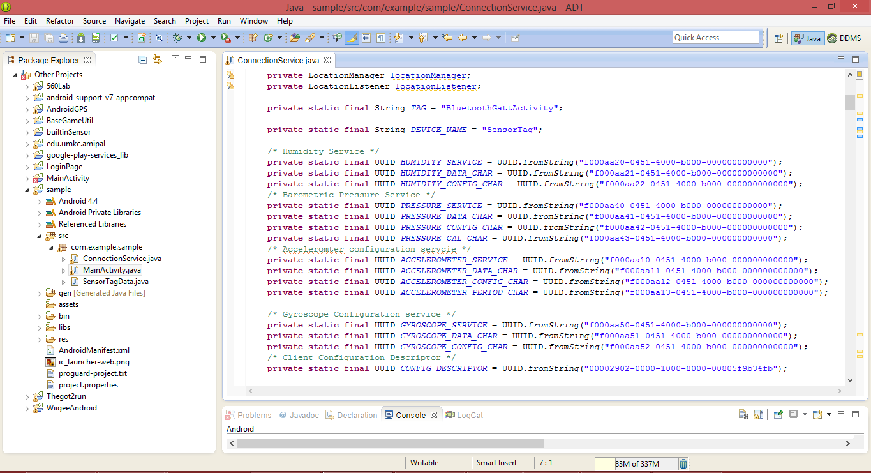

You can see the changes made in the application for the collection of data as follows.

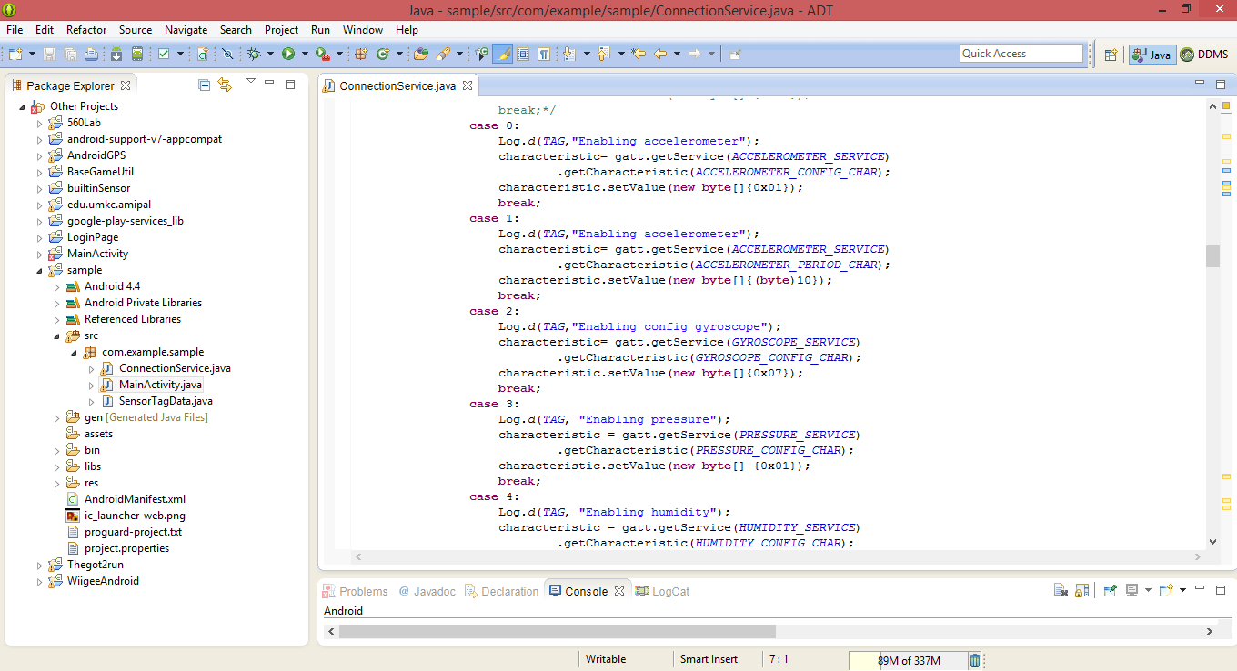

Different types of data is collected as follows in the text file as shown below.

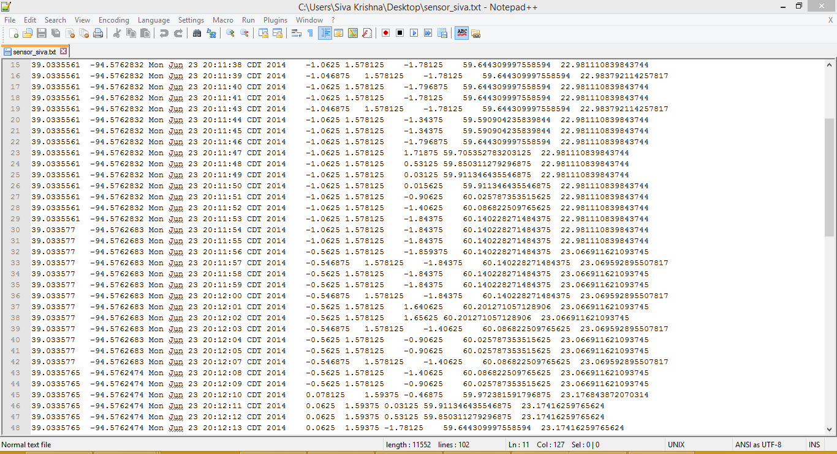

**Pushing Data:**

* The next task is to push this collected data into a HBase by the creation of tables.
* We are using a Application called HBase client to push the data to the HBase.
* Now we can run the application to create and push the data into HBase.
* Import the HBase client application into your eclipse and run as a java application.

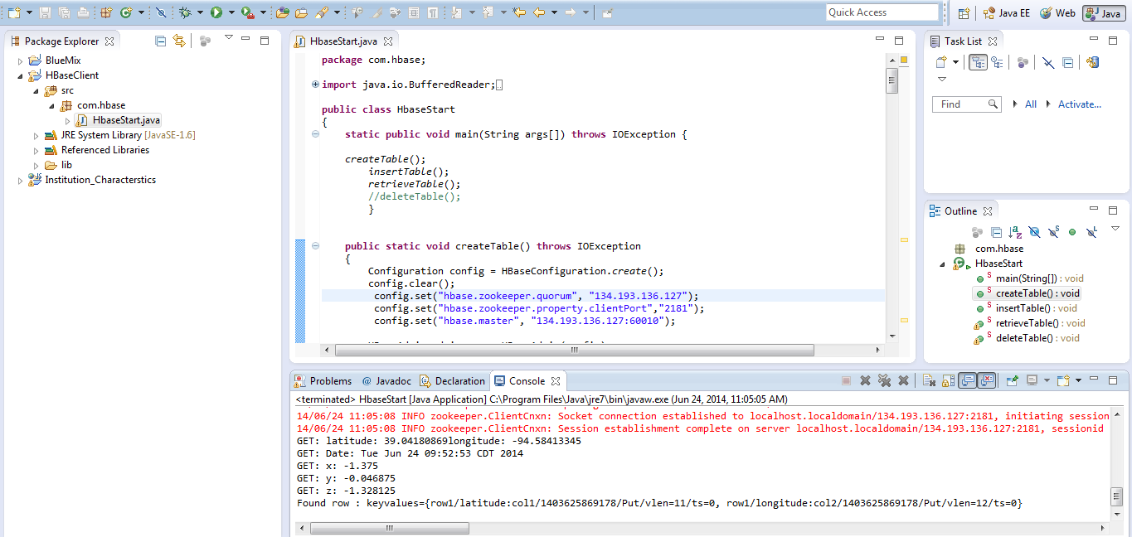

Make changes to the host in the system such that it connects to the local Cloudera installed in UMKC.

C:\Users\Siva Krishna\Desktop\table1.PNG

Now after running the application you can see the table created in the HBase as follows and data is pushed into HBase.

